**Existing Solution:**

1. **Amel (UAV)**

It is an Algerian design of drone. Its design and manufacture is Star Aviation. It took its first flight at 2013. Algerian Air force is the primary user of this drone. From 2013 to present it gives it services.



**Fig:1 Amel(UAV).**

1. **RedEdge-MX Dual Camera Imaging System**

This system has10-band multispectral solution incorporates the RedEdge-MX sensor and the new RedEdge-MX Blue, which features a new group of five filters including a coastal blue band and two new red edge bands. This is mainly designed to ensure easy data capture for research and drone/satellite comparisons, including applications such as shallow-water environmental monitoring and detailed chlorophyll efficiency analysis. To do comparison between satellite and drone data for efficient trend modelling ,The Dual Camera Imaging System is the first MicaSense product to capture the Landsat 8 and Sentinel satellite bands, allowing for direct data.The complete package includes an integrated quick mounting bracket and wiring harness for swift, easy attachment to DJI drones.

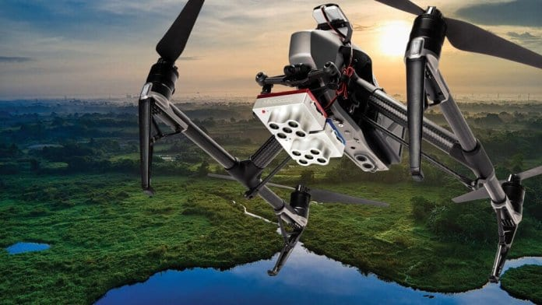

**Fig:2 RedEdge-MX Dual Camera Imaging System Drone.**

1. **Weather Sensors Aid Drone-Based Atmospheric Studies**

This project showed how UAV (unmanned aerial vehicle) manufacturers and researchers have used the company’s ultrasonic weather sensors to aid in drone-based atmospheric research and meteorological studies. Anemoment’s [TriSonica Mini Wind & Weather Sensor](https://anemoment.com/features/" \l "trisonica-mini" \t "_blank) is the world’s smallest and lightest 3D ultrasonic anemometer, providing high accuracy wind speed, direction, temperature, humidity, pressure, tilt, and compass data. Different companies selected this system for atmospheric research and meteorological studies.

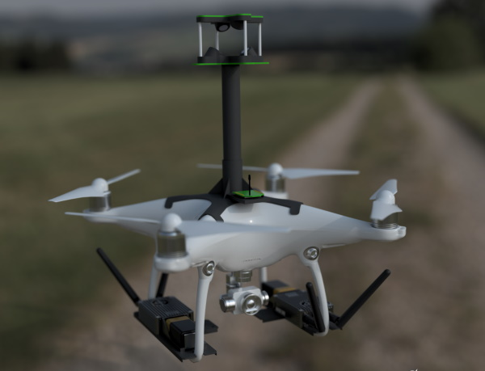

**Fig:3** Drone-based atmospheric research and meteorological studies.

1. **Drone-Based Electroluminescence Imaging of Solar Panels with SWIR Cameras**

[Raptor Photonics](https://www.raptorphotonics.com/) a famous company, has launched a drone explaining how its SWIR (short-wave infrared) cameras can be used in drone-based electroluminescence (EL) imaging of photovoltaic (PV) solar panels. To do high accuracy detection of defects and anything faults such as: broken cells, interconnections, cracks this system is perfect.

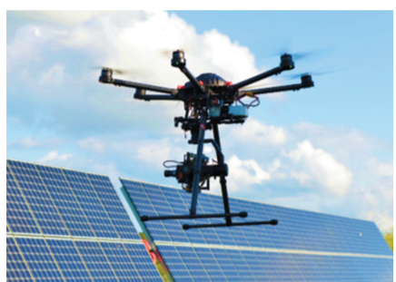

Fig: 4 Drone with Raptor 640 SWIR camera.

**References:**

1. [**https://www.unmannedsystemstechnology.com/wp-content/uploads/2019/10/MicaSense-DualCam-Multispectral-Drone-Imaging-Solution.jpg**](https://www.unmannedsystemstechnology.com/wp-content/uploads/2019/10/MicaSense-DualCam-Multispectral-Drone-Imaging-Solution.jpg)
2. [**https://www.unmannedsystemstechnology.com/wp-content/uploads/2020/01/TEN-TECH-LLC-Hurac%C3%A1n-Multi-Purpose-Aerial-Drone.jpg**](https://www.unmannedsystemstechnology.com/wp-content/uploads/2020/01/TEN-TECH-LLC-Hurac%C3%A1n-Multi-Purpose-Aerial-Drone.jpg)
3. [**https://i.ytimg.com/vi/SWjII7mxaZg/maxresdefault.jpg**](https://i.ytimg.com/vi/SWjII7mxaZg/maxresdefault.jpg)